**1. Introduction**

**1.1. Purpose of SRS**

This SRS document specify requirements for creating of ‘HYU ERICA mini (for Student)’ application

**1.2. Scope of product**

‘HYU ERICA mini (for Student)’ application is intented for students at Hanyang University ERICA campus.

**1.3. Definitions, Acronyms and Abbreviations**

REST : Representational State Transfer

App : Application

HYU : Hanyang University

UI : User Interface

UX : User Experience

API : Application Programming Interface

**1.4. References**

Hanyang university API : <https://api.hanyang.ac.kr/>

**2. General Description**

**2.1. Product Perspective**

This product is intended for students attending Hanyang University ERICA campus.

Basically, Mainly focused on the development function is being commonly used by students.

**2.2. Product Functions**

The following functions are implemented.

* Weekly Meal Menu
* Shuttle Bus Time Table
* Student Timetable
* Mobile Student ID
* Community Board

**2.3. User Characteristics**

User range is bounded to students attending Hanyang University ERICA campus.

And because of age groups is commonly from 20 early to mid, using smart phone is very familiar. They live in almost predetermined pattern.

**2.4. Constraints**

All contents must be accessed by under 4 times touching in main screen.

Using students timetable and mobile student id, community board are available only login.

**2.5. Assumptions and Dependencies**

The Hanyang University API provided should be used for implementing all product’s functions.

**3. Specific Requirements**

**3.1. External Interface Requirements**

**3.1.1. User Interface**

**3.1.1.1. Weekly Meal Menu**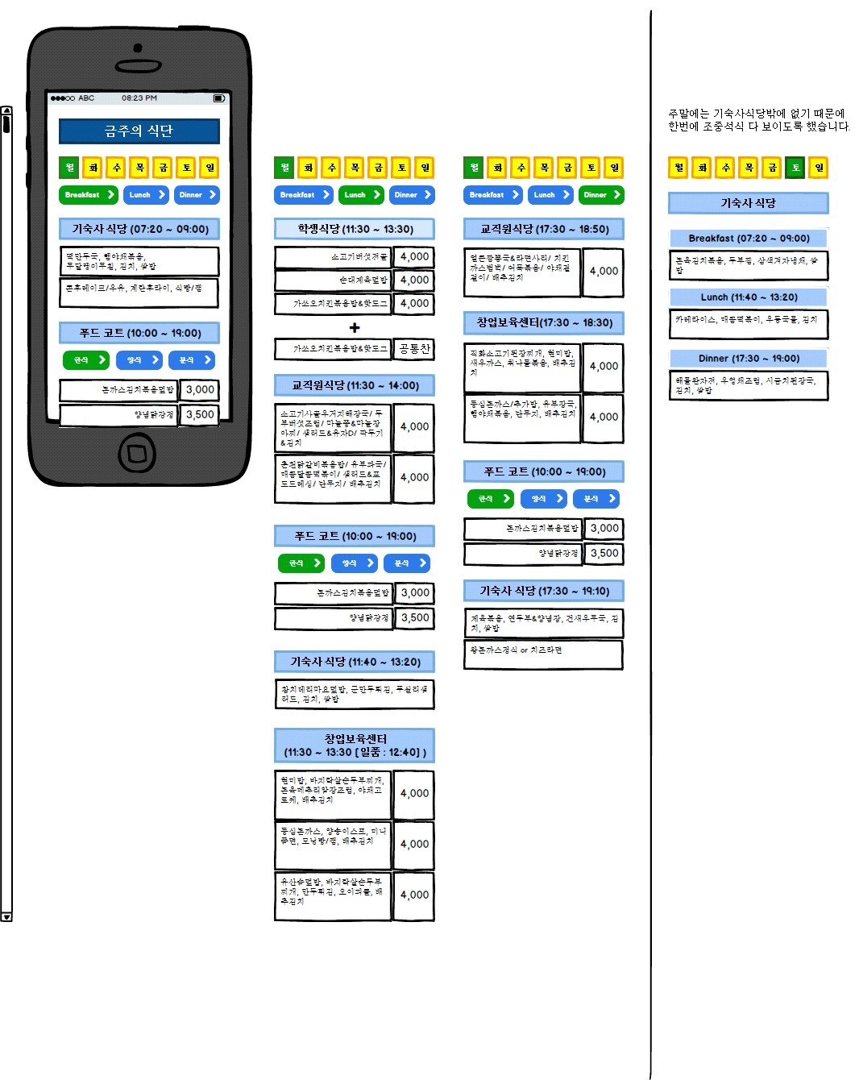

**3.1.2. Software Interface**

**3.1.2.1. Back Button**

Return to application’s main screen.

**3.2. Functional Requirements**

**3.2.1. Weekly Meal Menu**

Show weekly meal menu for ‘dormitory cafeteria’, ‘food court’, ‘students cafeteria’,

‘college employee cafeteria’, ‘business incubator center cafeteria’ by day of week,

by time at a glance.

**3.2.1.1. Show weekly meal menu**

**3.2.1.1.1. Introduction/Purpose of feature:**

Show each meal menu by day of week.

**3.2.1.1.2. Stimulus/Response sequence**

If each button for day of week is touched, all meal table for all restraunt is shown.

case Saturday, a meal table for ‘domitory cafeteria’ is only shown.

**3.2.1.2. Show meal table by time**

**3.2.1.2.1. Introduction/Purpose of feature**

Meal table, shown by day of weeks, are reshown by time.

**3.2.1.2.2. Stimulus/Response sequence**

If ‘Breakfast’, ‘Lunch’ and ‘Dinner’ button is pushed, meal table is shown for each time;

(Time is just ‘Breakfast’, ‘Lunch’ and ‘Dinner’ not specific time(ex: 11:00 ~ 13:30).)

**3.2.1.3. Show ‘food court’ meal table by category**

**3.2.1.3.1. Introduction/Purpose of feature**

Among the meal tables,’food court’ meal table is shown by category, ‘korean meal’, ‘western meal‘ and ‘flour-based meal’

**3.2.1.3.2. Stimulus/Response sequence**

If ‘korean meal’, ‘western meal‘ and ‘flour-based meal’ button pushed, meal table is shown by category.

**3.4. Design Constraints**

**3.4.1 Constraint 1**

All restaurant’s menu must be shown in one layout, not need to select restaurant..

**3.4.1 Constraint 2**

Each restraunt’s location should be simply checked by user